**NGO search and rescue in the Mediterranean - state of play**

Rights areas:

* [Asylum, migration and borders](https://fra.europa.eu/en/taxonomy/term/962)

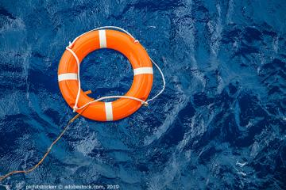

Over six people per day on average died crossing the Mediterranean Sea to reach Europe in 2018. Tougher migration policies have been undermining civil society rescue efforts to save lives and bring migrants in distress at sea to safety, as recent FRA research shows.

**Publication**

[**Fundamental rights considerations: NGO ships involved in search and rescue in the Mediterranean and criminal investigations - 2018**](https://fra.europa.eu/node/36774)

Civil society tries to help save migrants fleeing war or persecution, or seeking a better life, whose lives have been put at risk by unscrupulous people, smugglers and traffickers.

EU Member States are cracking down on civil society rescue vessels by launching criminal and administrative proceedings against NGOs or other private entities involved in search and rescue operations (SAR) in the Mediterranean.

Member States seized vessels and arrested crew members, initiating legal procedures against them. In some cases, they blocked rescue vessels in harbours due to flag issues. This led most NGOs to stop their search and rescue operations, as [FRA already noted in 2018](https://fra.europa.eu/en/publication/2018/ngos-sar-activities).

[Fresh research by FRA](https://fra.europa.eu/en/publication/2019/2019-update-ngos-sar-activities) provides a snapshot on developments since August 2018 up until June 2019.

The update gives an overview of all NGOs and their vessels and reconnaissance aircrafts involved in Mediterranean search and rescue operations since 2016. It also indicates whether they have been subject to legal proceedings.

This reveals how only a few NGO rescue vessels were operational in June 2019 due to various reasons, including ship seizures or de-flagging ordered by Member States.

It also points to ongoing or closed investigations and administrative or criminal proceedings against private entities involved in search and rescue as of June 2019. This shows that although more Member States opened such legal cases compared to last year, many opened cases ended with an acquittal or were discontinued due to the lack of evidence; others are still pending at the time of this update.

Some NGOs and private individuals have countered these actions. They have initiated counter-claims, citing aggravated slander and defamation. They have also turned to the European Court of Human Rights, asking the Court to allow interim measures to assist rescued migrants on board.

FRA will keep following further developments and reporting on this through its [quarterly bulletins](https://fra.europa.eu/en/theme/asylum-migration-borders/overviews) on migration-related fundamental rights concerns covering 15 selected EU Member States.